Guidance on applying sail numbers and national letters to new Topper sails.

Before you sail your new boat, it is most important to apply the self-adhesive numbers to the sail first. The sail numbers are exclusive to the boat and correspond to the World Sailing Building Plaque displayed on the forward bulkhead in the cockpit or in older boats the embossed metal plate on the aft bulkhead of the cockpit.
Follow these instructions carefully - it is not a job to be hurried and will usually take about 90 minutes to complete.
Work on a large flat surface, for instance a wooden floor or large table. Use a ruler and pencil to accurately draw lines.
The best way to stick the numbers down is to peel away a corner, line up the letter and then attach the corner. Pull away the backing paper slowly as you push the number onto the sail.

Where a measurement of 45-55mm is given, we suggest using a measurement of 50mm to give tolerance either way.

Measurements shall be taken from the lower edge of the seam unless stated.

‘National Letters’ refers to MNA Country Codes.

Class rules require that Topper sail numbers shall be constructed of ‘digital eights’ cut in the preferred style. Serifs shall be 10mm ± 3mm. The height of the numbers shall be 230mm.

These instructions are guidelines only. If in doubt, check the current Class Rules or ask
Technical@itcaworld.org

Topper 5.3 - SAIL NUMBERS:
- Sail numbers shall be placed on both sides of the sail with the numbers on the starboard side being above the ones on the port side.
- National letters shall be placed in the panel below the Top Hat logo and the sail numbers in the panel below the National letters.
- The height of the numbers shall be 230mm (-0mm).
- The numbers are supplied as ‘digital eights’ from which you can produce your own sail number.
- There shall be 45-55mm between each digit of the complete number.
- The sail numbers shall be black.

STARBOARD SIDE:
- The upper edge of the starboard numbers shall be placed 45-55mm from the continuously straight edge of the seam of that panel (by drawing a pencil line through the dart of the seam).
- Sail numbers shall start 45-55mm from the Leech (aft edge of the sail).

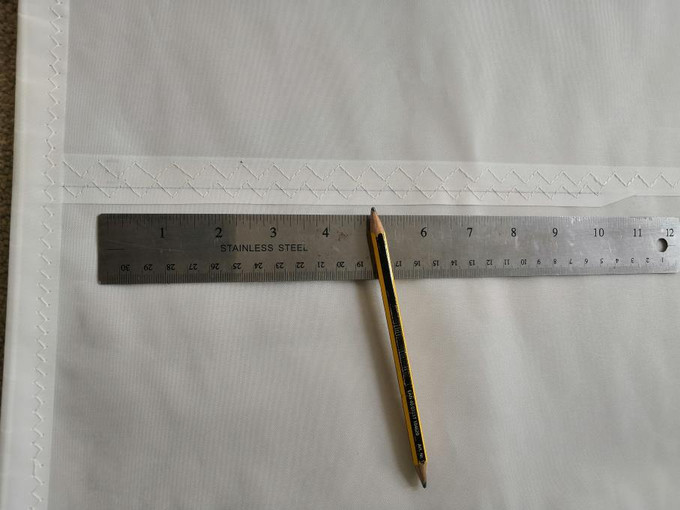
1) Draw a line through the dart of the seam in line with the long length of seam.

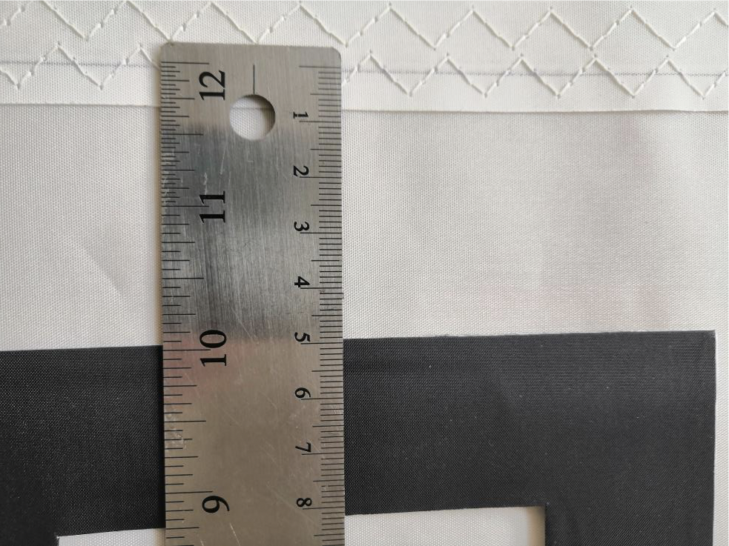
2) Measure 50mm from the line in the dart of the seam and draw a line parallel with the seam.

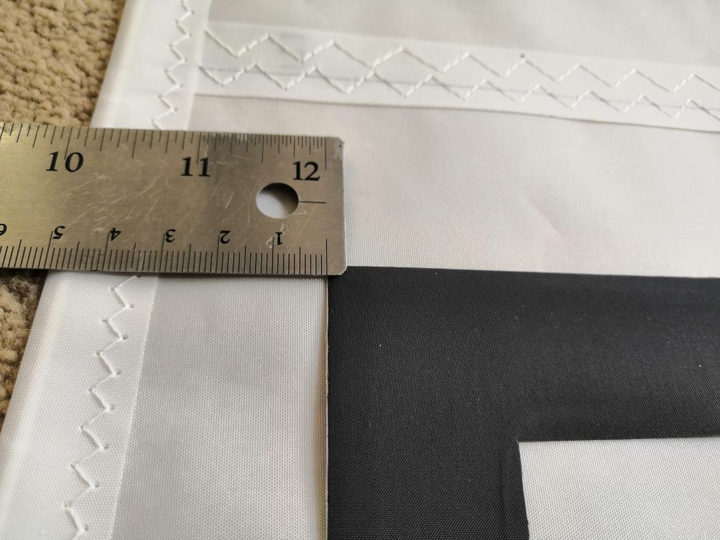
3) Measure 50mm in from leech.

PORT SIDE:
- The upper edge of the port numbers shall be placed 45-55mm below the starboard side numbers.
- They shall finish 45-55mm from the Leech (aft edge of the sail).

* NOTE: Topper Sail Numbers are derived from digital 8 numbers from which any number from 0-9 can be obtained. Ten digital 8 numbers are supplied.

Topper 5.3 - NATIONAL LETTERS:
- National letters shall be placed on both sides of the sail with the letters on the starboard side being placed above those on the port side.
- They shall be placed in the panel beneath the Top Hat logo.
- The height of the letters shall be 230mm (-0mm).
- They shall be pre-formed Helvetica letters.
- There shall be 45-55mm between each letter.
- The letters shall be black.

STARBOARD SIDE:
- The upper edge of the starboard letters shall be placed 45-55mm from the continuously straight edge of the seam of that panel (by drawing a pencil line through the dart of the seam).
- National letters shall start 45-55mm from the Leech (aft edge of the sail).

PORT SIDE:
- The upper edge of the port letters shall be placed 45-55mm below the starboard side letters.
- They shall finish 45-55mm from the Leech (aft edge of the sail).

Topper 5.3 - EVENT/CHAMPIONSHIP NUMBERS:
- Event/Championship numbers shall be placed on both sides of the sail with the numbers on the starboard side being above those on the port side.
- The height of the numbers shall be 230mm (-0mm).
- The numbers are supplied as ‘digital eights’ from which you can produce your own Event/Championship number.
- There shall be 45-55mm between each digit of the complete number.
- Both sets of numbers shall be placed in the 2nd coloured panel up from the bottom of the sail.
- The Event/Championship numbers shall be white.

STARBOARD SIDE:
- The upper edge of the starboard numbers shall be placed 45-55mm from the continuously straight edge of the seam of that panel (by drawing a pencil line through the dart of the seam).
- Event/Championship numbers shall start 45-55mm from the Leech (aft edge of the sail).

PORT SIDE:
- The upper edge of the port numbers shall be placed 45-55mm below the starboard side numbers.
- They shall finish 20-25mm from the reinforcement patch.

Topper 4.2 - SAIL NUMBERS:
Please refer to the photos above of the Topper 5.3 sail for positioning sail numbers.
- Sail numbers shall be placed on both sides of the sail with the numbers on the starboard side being above the ones on the port side.
- Sail numbers shall be placed in the panel below the Top Hat logo.
- The height of the numbers shall be 230mm (-0mm).
- The numbers are supplied as ‘digital eights’ from which you can produce your own sail number.
- There shall be 45-55mm between each digit of the complete number.
- The sail numbers shall be black.

STARBOARD SIDE:
- The upper edge of the starboard numbers shall be placed 45-55mm from the upper seam of that panel.
- Sail numbers shall start 45-55mm from the Leech (aft edge of the sail).

PORT SIDE:
- The upper edge of the port numbers shall be placed 45-55mm below the starboard side numbers.
- They shall finish 45-55mm from the Leech (aft edge of the sail).

Topper 4.2 - NATIONAL LETTERS:
- National letters shall be placed on both sides of the sail with the letters on the starboard side being above the ones on the port side.
- They shall be placed in the panel beneath the sail numbers.
- The height of the letters shall be 230mm (-0mm).
- They shall be pre-formed Helvetica letters.
- There shall be 45-55mm between each letter.
- The letters shall black.
STARBOARD SIDE:
- The upper edge of the starboard letters shall be placed 45-55mm from the upper seam of that panel.
- National letters shall start 45-55mm from the Leech (aft edge of the sail).

PORT SIDE:
- The upper edge of the port letters shall be placed 45-55mm below the starboard side letters.
- They shall finish 45-55mm from the Leech (aft edge of the sail).

Topper 4.2 - EVENT/CHAMPIONSHIP NUMBERS:
- Event/Championship numbers shall be placed on both sides of the sail with the numbers on the starboard side being above the ones on the port side.
- The height of the numbers shall be 230mm (-0mm).
- The numbers are supplied as ‘digital eights’ from which you can produce your own Event/Championship number.
- There shall be 45-55mm between each digit of the complete number.
- The Event/Championship numbers shall be white.

STARBOARD SIDE:
- The starboard numbers shall be placed in the coloured panel 2nd up from the bottom of the sail.
- The lower edge of the starboard numbers shall be placed 45-55mm from the upper edge of the lower seam of the panel.
- Event/Championship numbers shall start 20-25mm from the reinforcement patch.

PORT SIDE:
- The port numbers shall be placed in the bottom coloured panel.
- The upper edge of the port numbers shall be placed 20-25mm from the top seam of that panel.
- They shall finish 20-25mm from the reinforcement patch.

